PROJECT DOCUMENTATION

**PROJECT MANDATE**

|  |  |
| --- | --- |
| **Project: Designing a Management System for Chandrika Agri Centre** |  |
| Release: 23 February 2019 |  |
| Date: May 2019 |  |
|  |  |
| **PRINCE2** |  |
|  |  |
| Author: Udara Jayawardhane |  |
| Owner: Dr. Yasas Jayaweera |  |
| Client: Chandrika Agri Centre |  |
| Document Ref: CAC Management System Project Mandate |  |
| Version No: 1.0 |  |

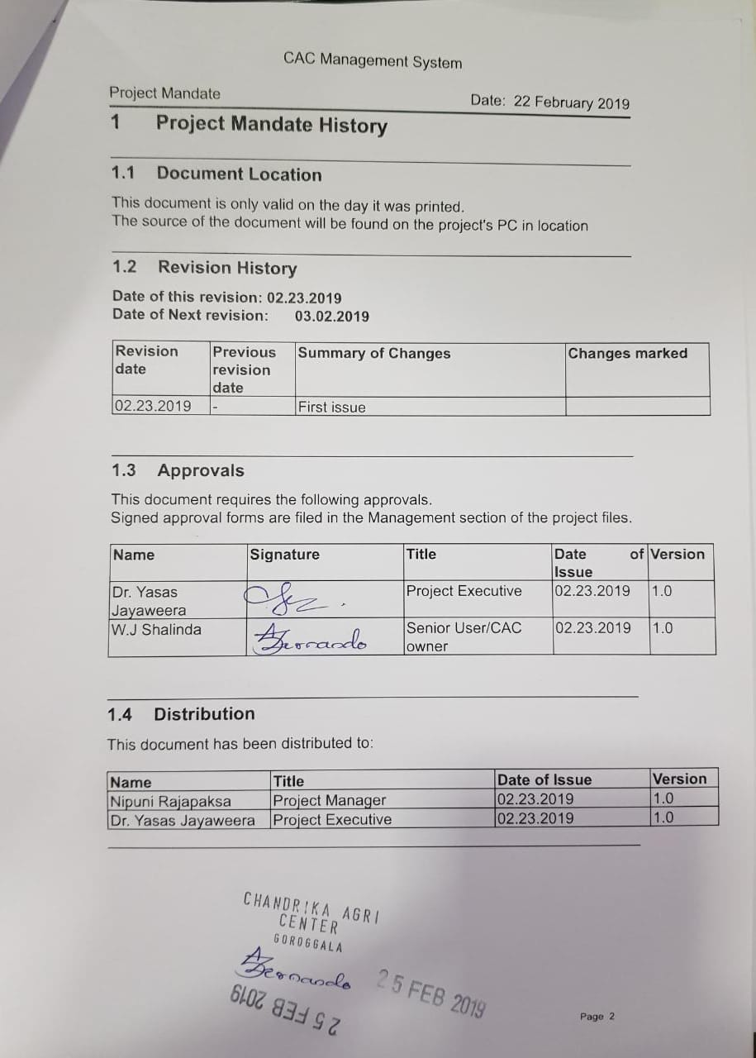

# 2 Table of Contents

### 1 Project Mandate History

1.1 Document Location

1.2 Revision History

1.3 Approvals

1.4 Distribution

### 2 Table of Contents

### 3 Purpose

### 4 Authority Responsible

### 5 Background

### 6 Project Objectives

### 7 Scope

### 8 Constraints

### 9 Interfaces

### 10 Quality Expectations

### 11 Outline Business Case

### 12 Associated Documents

### 13 Proposed Project Executive and Project Manager

### 14 Customer and Users

# Project Mandate

## 3 Purpose

Chandrika Agri Center is currently a emerging manufacturer & provider of fertilizer in Sri Lanka, which is a stern pillar in building the economic infrastructure of any country. Currently as it stands, in 2019, the company consists of several segmented processes handled by about 25 employees and a corporate team for the administrative task performances.

With the budding of the company and upscaling being prominent at the time of concern, the management sector pertinent to performing administrative functions is in need of a control system in place to avoid complications and efficiency compromises that are potentially viable for any emerging company.

This is where the project team led by the project manager would step in, by offering to implement a software solution to monitor the systematic flow of work within the company relevant to the process of manufacturing as well as employee evaluation. This will include relevant components for these management purposes and will enable Chandrika Agri Centre to move forward in the business world with one foot firmly planted on a profitable business.

## 4 Authority Responsible

**Dr. Yasas Jayaweera (Project Executive)   
Owner/ Proprietor of Chandrika Agri Centre (Senior User)**

## 5 Background

Agriculture is an important aspect of the Sri Lankan economy and it has been that way since a long time. Albeit the current scale of branching, Chandrika Agri Centre is second to none in its forte which is the manufacture and provision of fertilizer for agricultural purposes. With economy of the country depending on the agriculture based industries at large, Chandrika Agri Centre needs to be ahead of their competition always. This concerns not only product quality assurance, but also process efficiency in delivering products as well.

The systematic approach to deploy the software solution would provide enough edge for the client to reinforce the efficiency of company workforce and reduce multiple overheads associated with extra labour and other costs. Thus staying ahead of competitors with the aid of the project outcome would be beneficial for solidifying the company reputation and favourable marketing as well.

## 6 Project Objectives

* To analyse existing system that are being used by client and identify drawbacks.
* To provide a smoothly operating, user friendly management system that overcomes current drawbacks of the existing system.
* To investigate specific areas of functionality, which are known to be needed.
* To meet user requirements by getting customer satisfaction.
* To produce best practice documentation.

## 7 Scope

The scope of the project mainly includes implementing a new management system for the client to enhance the day-to-day management activities using a software tool comprising of simple layouts.

The project will be segmented into the below categories as initially discussed and planned with reference to client requirements.

-Process Management  
 -Inventory Management

-Machinery Management

-Employee Management

-Stock Management

The stages of the project will be considered according to the previously mentioned partitioning of the artefact and will be evaluated according to Prince2 project management methodology.

## 8 Constraints

Limitations and boundaries put on regarding the realization of the artefact by the client would prove as a constraint in building a much more interconnected system. However the team will provide the client what they desire while adhering to these constraints to avoid ethical and legal dilemmas.

The project team consists of five members, of which some are currently working on internships. This will limit their ability to perform tasks ideally to a certain extent, but the team will work around the issue by properly distributing workloads apropos to the individual state of affairs, to reduce friction in manageability.

## 9 Interfaces

This project is being undertaken to provide Chandrika Agri Centre with their first software solution regarding managing their enterprise, and hence involves no links to any other previous or current projects relevant to the CAC management system.

However, probable internal and external interfaces with which interactions could be observed are as follows.

-Owner -Technical Interfaces

-Employees -Information Interfaces

-Competitors -Review points

-Time Interfaces -Major breakpoints/ issue interfaces

-Social Interfaces -Operations/ Management Interfaces

## 10 Quality Expectations

As per the analysis of the project initiation request discussion, the client requires the following basic features/ abilities as qualitative expectations.

-Simple user interfaces

-Simple language and easy comprehensibility of the final deliverable

-Unified theme across all sub systems of the scope considered

-The system must be run on Windows OS platform with existing hardware

-The system must have a screen resolution suitable for the existing 1280x720 screens

Furthermore, the deliverables will tested at each stage against these quality standards, by the Quality Assurance representative of the project team.

## 11 Outline Business Case

Aligning this project with a business strategy provides benefits, such as more efficient investment of time and reduced cost of resources. Additionally, opportunities and potential dangers can be spotted during the project.

Expected benefits:

* Cost savings by reducing paperwork.
* Cost savings by reducing the number of failed agricultural products
* Cost savings by efficient usage of resources

Furthermore in short term benefits, the company would be able to reduce lead time for manufacturing products, while increasing efficiency and employee morale. In long term, these would translate in to considerable increments in overall profitability of the company, allowing the client to advance in acquiring better assets for future proofing the guaranteed service.

## 12 Associated Documents

Not Applicable.  
(References to estimated project size, time scope and risks are mentioned in the project brief)

## 13 Proposed Executive and Project Manager

Dr. Yasas Jayaweera (Executive) and Nipuni Rajapaksa (Project Manager)

## 14 Customers and Users

Customer: Chandrika Agri Centre

Primary Users: Administrative Division of Chandrika Agri Centre, Project Team